Name : Thota Anil Raj

Reg. No : 11601794

Section : K1616

Roll No. : B40

E-mail : [anilrajthota@gmail.com](mailto:anilrajthota@gmail.com)

Github ID : AnilRaj27

**Question No. 1**

The problem number – 8, is to build an algorithm which can be used on a scheduler to show the multiple requests for the user. The processes arrival time, burst time and time quantum are entered by the user. The algorithm used in this question is ‘Round Robin algorithm’ to deal with the process provided by the user. Each process deals with the given time quantum and calculates the total time taken and gives the average querying time.

In problem number – 9, two queues are to be simulated that is ready queue and execution queue. Where the ready queue changes at the rate of 2 dynamically and the execution queue changes at the rate of 1 dynamically the ‘Priority Scheduling Algorithms’ deals with the processes provided by the user.

**Question No. 2**

Algorithm for Problem – 8:

1. Take input from the user about the arrival and burst time and Time quantum.
2. Consider two structures one is for student and another for faculty
3. The structures which has attributes about the process and stores all those values.
4. Take another array and store all the values of burst time.
5. As the burst time is changed by the time quantum value given by the user.
6. Take flag values and perform the logic for calculating total time and average query time.
7. Similarly take the input requests given by the faculty and compute the values by going to step2.

Algorithm for Problem – 9:

1. Take input from the user about the arrival time, burst time and he priority of each process.
2. Consider a structure which has attributes about the process and stores all those values.
3. Sort the values according to their priority.
4. Initialize the wait value to zero and perform the logic with the burst time.
5. Calculate the average waiting time.
6. Display it accordingly using for loop.

**Question No. 3**

Problem No. 8

Complexity: O (n2)

The complexity specified above is the worst-case scenario.

Where n is the size of input.

Problem No. 9

Complexity: O (n2)

The complexity specified above is the worst-case scenario.

Where n is the size of input.

**Question No. 4**

*Problem No 8*

Time quantum is of 5.

A screenshot of a social media post

Description generated with very high confidence

*A screenshot of a social media post

Description generated with very high confidence*

*A screenshot of a social media post

Description generated with very high confidence*

*Problem No 9*

*A screenshot of a social media post

Description generated with very high confidence*

*A screenshot of a social media post

Description generated with very high confidence*

**Question No. 5**

The additional algorithm used in the both the problems is to sort the objects of the structures according to the arrival time and burst time.

**Question No. 6**

The boundary conditions of the algorithm used in both the question is the number of input cases. Which in this case is given 20 input-size.

**Question No. 7**

Test – Cases

*Problem No. 8*

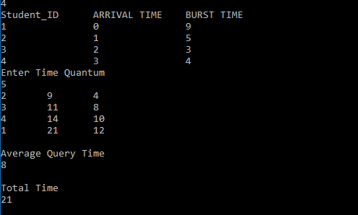

*Problem No. 9*

*A screen shot of a computer

Description generated with very high confidence*

**Question No. 8**

No, I’ve uploaded the project but did not create 5 revisions of it previously.